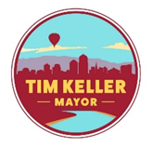

Mayor’s Youth Advisory Council
Thursday April 4th, 2019

- Call to Order
- Announcements
- Changes and/or additions to the agenda
- Diana Delgado
- Yearly project discussion and vote
- GARE Annual Membership Meeting
- Work with Youth Connect
- Adjournment

*Next Meeting: May 2nd, 2019, 5:30PM @ Mayor’s Conference Room

